|  |  |
| --- | --- |
| **Ex.No:** 1 | **Study of necessary header files with respect to socket programming** |
| **Date:** |

**Description:**

1. **stdio.h:** Has standard input and output library providing simple and efficient buffered stream IO interface.
2. **unistd.h:** It is a POSIX standard for open system interface. [Portable Operating System Interface
3. **string.h:** This header file is used to perform string manipulation operations on NULL terminated strings.(Bzero -0 the m/y)
4. **stdlib.h:** This header file contains the utility functions such as string conversion routines, memory allocation routines, random number generator, etc.
5. **sys/types.h:** Defines the data type of socket address structure in unsigned long.
6. **sys/socket.h:** The socket functions can be defined as taking pointers to the generic socket address structure called sockaddr.
7. **netinet/in.h:** Defines the IPv4 socket address structure commonly called Internet socket address structure called sockaddr_in.
8. **netdb.h:** Defines the structure hostent for using the system call gethostbyname to get the network host entry.
9. **time.h:** Has structures and functions to get the system date and time and to perform time manipulation functions. We use the function ctime(), that is defined in this header file, to calculate the current date and time.
10. **sys/stat.h:** Contains the structure stat to test a descriptor to see if it is of a specified type. Also it is used to display file or file system status.stat() updates any time related fields when copying from 1 file to another.
11. **sys/ioctl.h:** Macros and defines used in specifying an ioctl request are located in this header file. We use the function ioctl() that is defined in this header file. ioctl() function is used to perform ARP cache operations.
12. **pcap.h:** Has function definitions that are required for packet capturing. Some of the functions are pcap_lookupdev(),pcap_open_live() and pcap_loop(). pcap_lookupdev() is used to initialize the network device.The device to be sniffed is opened using the pcap_open_live(). Pcap_loop() determines the number of packets to be sniffed.
13. **net/if_arp.h:** Contains the definitions for Address Resolution Protocol. We use this to manipulate the ARP request structure and its data members arp_pa,arp_dev and arp_ha. The arp_ha structure’s data member sa_data[ ] has the hardware address.
14. **errno.h:** It sets an error number when an error and that error can be displayed using perror function. It has symbolic error names. The error number is never set to zero by any library function.
15. **arpa/inet.h:** This is used to convert internet addresses between ASCII strings and network byte ordered binary values (values that are stored in socket address structures). It is used for inet_aton, inet_addr, inet_ntoa functions

## Package java.net Description

Provides the classes for implementing networking applications.

**Sockets** Sockets are means to establish a communication link between machines over the network. The java.net package provides 4 kinds of Sockets:

* [Socket](https://docs.oracle.com/javase/7/docs/api/java/net/Socket.html) is a TCP client API, and will typically be used to [connect](https://docs.oracle.com/javase/7/docs/api/java/net/Socket.html#connect(java.net.SocketAddress)) to a remote host.
* [ServerSocket](https://docs.oracle.com/javase/7/docs/api/java/net/ServerSocket.html) is a TCP server API, and will typically [accept](https://docs.oracle.com/javase/7/docs/api/java/net/ServerSocket.html#accept()) connections from client sockets.
* [DatagramSocket](https://docs.oracle.com/javase/7/docs/api/java/net/DatagramSocket.html) is a UDP endpoint API and is used to [send](https://docs.oracle.com/javase/7/docs/api/java/net/DatagramSocket.html#send(java.net.DatagramPacket)) and [receive](https://docs.oracle.com/javase/7/docs/api/java/net/DatagramSocket.html#receive(java.net.DatagramPacket)) [datagram packets](https://docs.oracle.com/javase/7/docs/api/java/net/DatagramPacket.html).
* [MulticastSocket](https://docs.oracle.com/javase/7/docs/api/java/net/MulticastSocket.html) is a subclass of DatagramSocket used when dealing with multicast groups.

Sending and receiving with TCP sockets is done through InputStreams and OutputStreams from

the [Socket.getInputStream()](https://docs.oracle.com/javase/7/docs/api/java/net/Socket.html#getInputStream()) and [Socket.getOutputStream()](https://docs.oracle.com/javase/7/docs/api/java/net/Socket.html#getOutputStream()) methods. These methods are available in the **java.io** package.

|  |  |
| --- | --- |
| **CLASS** | **DESCRIPTION** |
| [Authenticator](https://docs.oracle.com/javase/7/docs/api/java/net/Authenticator.html) | The class Authenticator represents an object that knows how to obtain  authentication for a network connection. |
| [CacheRequest](https://docs.oracle.com/javase/7/docs/api/java/net/CacheRequest.html) | Represents channels for storing resources in the ResponseCache. |
| [CacheResponse](https://docs.oracle.com/javase/7/docs/api/java/net/CacheResponse.html) | Represent channels for retrieving resources from the ResponseCache. |
| [ContentHandler](https://docs.oracle.com/javase/7/docs/api/java/net/ContentHandler.html) | The abstract class ContentHandler is the superclass of all classes that  read an Object from a URLConnection. |
| [CookieHandler](https://docs.oracle.com/javase/7/docs/api/java/net/CookieHandler.html) | A CookieHandler object provides a callback mechanism to hook up |

|  |  |
| --- | --- |
|  | a HTTP state management policy implementation into the HTTP protocol handler. |
| [CookieManager](https://docs.oracle.com/javase/7/docs/api/java/net/CookieManager.html) | CookieManager provides a concrete implementation of [CookieHandler](https://docs.oracle.com/javase/7/docs/api/java/net/CookieHandler.html),  which separates the storage of cookies from the policy surrounding  accepting and rejecting cookies. |
| [DatagramPacket](https://docs.oracle.com/javase/7/docs/api/java/net/DatagramPacket.html) | This class represents a datagram packet. |
| [DatagramSocket](https://docs.oracle.com/javase/7/docs/api/java/net/DatagramSocket.html) | This class represents a socket for sending and receiving datagram packets. |
| [DatagramSocketIm](https://docs.oracle.com/javase/7/docs/api/java/net/DatagramSocketImpl.html) [pl](https://docs.oracle.com/javase/7/docs/api/java/net/DatagramSocketImpl.html) | Abstract datagram and multicast socket implementation base class. |
| [HttpCookie](https://docs.oracle.com/javase/7/docs/api/java/net/HttpCookie.html) | An HttpCookie object represents an http cookie, which carries state  information between server and user agent. |
| [HttpURLConnection](https://docs.oracle.com/javase/7/docs/api/java/net/HttpURLConnection.html) | A URLConnection with support for HTTP-specific features. |
| [IDN](https://docs.oracle.com/javase/7/docs/api/java/net/IDN.html) | Provides methods to convert internationalized domain names (IDNs) between a normal Unicode representation and an ASCII Compatible Encoding (ACE) representation. |
| [Inet4Address](https://docs.oracle.com/javase/7/docs/api/java/net/Inet4Address.html) | This class represents an Internet Protocol version 4 (IPv4) address. |
| [Inet6Address](https://docs.oracle.com/javase/7/docs/api/java/net/Inet6Address.html) | This class represents an Internet Protocol version 6 (IPv6) address. |
| [InetAddress](https://docs.oracle.com/javase/7/docs/api/java/net/InetAddress.html) | This class represents an Internet Protocol (IP) address. |
| [InetSocketAddress](https://docs.oracle.com/javase/7/docs/api/java/net/InetSocketAddress.html) | This class implements an IP Socket Address (IP address + port number)  It can also be a pair (hostname + port number), in which case an attempt will be  made to resolve the hostname. |
| [InterfaceAddress](https://docs.oracle.com/javase/7/docs/api/java/net/InterfaceAddress.html) | This class represents a Network Interface address. |
| [JarURLConnection](https://docs.oracle.com/javase/7/docs/api/java/net/JarURLConnection.html) | A URL Connection to a Java ARchive (JAR) file or an entry in a JAR file. |
| [MulticastSocket](https://docs.oracle.com/javase/7/docs/api/java/net/MulticastSocket.html) | The multicast datagram socket class is useful for sending and receiving IP multicast packets. |
| [NetPermission](https://docs.oracle.com/javase/7/docs/api/java/net/NetPermission.html) | This class is for various network permissions. |
| [NetworkInterface](https://docs.oracle.com/javase/7/docs/api/java/net/NetworkInterface.html) | This class represents a Network Interface made up of a name, and a list of IP addresses assigned to this interface. |
| [PasswordAuthentic](https://docs.oracle.com/javase/7/docs/api/java/net/PasswordAuthentication.html) [ation](https://docs.oracle.com/javase/7/docs/api/java/net/PasswordAuthentication.html) | The class PasswordAuthentication is a data holder that is used by Authenticator. |

|  |  |
| --- | --- |
| [Proxy](https://docs.oracle.com/javase/7/docs/api/java/net/Proxy.html) | This class represents a proxy setting, typically a type (http, socks) and a socket address. |
| [ProxySelector](https://docs.oracle.com/javase/7/docs/api/java/net/ProxySelector.html) | Selects the proxy server to use, if any, when connecting to the network resource referenced by a URL. |
| [ResponseCache](https://docs.oracle.com/javase/7/docs/api/java/net/ResponseCache.html) | Represents implementations of URLConnection caches. |
| [SecureCacheRespo](https://docs.oracle.com/javase/7/docs/api/java/net/SecureCacheResponse.html) [nse](https://docs.oracle.com/javase/7/docs/api/java/net/SecureCacheResponse.html) | Represents a cache response originally retrieved through secure means, such as TLS. |
| [ServerSocket](https://docs.oracle.com/javase/7/docs/api/java/net/ServerSocket.html) | This class implements server sockets. |
| [Socket](https://docs.oracle.com/javase/7/docs/api/java/net/Socket.html) | This class implements client sockets (also called just "sockets"). |
| [SocketAddress](https://docs.oracle.com/javase/7/docs/api/java/net/SocketAddress.html) | This class represents a Socket Address with no protocol attachment. |
| [SocketImpl](https://docs.oracle.com/javase/7/docs/api/java/net/SocketImpl.html) | The abstract class SocketImpl is a common superclass of all classes that actually implement sockets. |
| [SocketPermission](https://docs.oracle.com/javase/7/docs/api/java/net/SocketPermission.html) | This class represents access to a network via sockets. |
| [StandardSocketOpt](https://docs.oracle.com/javase/7/docs/api/java/net/StandardSocketOptions.html) [ions](https://docs.oracle.com/javase/7/docs/api/java/net/StandardSocketOptions.html) | Defines the standard socket options. |
| [URI](https://docs.oracle.com/javase/7/docs/api/java/net/URI.html) | Represents a Uniform Resource Identifier (URI) reference. |
| [URL](https://docs.oracle.com/javase/7/docs/api/java/net/URL.html) | Class URL represents a Uniform Resource Locator, a pointer to a "resource" on the World Wide Web. |
| [URLClassLoader](https://docs.oracle.com/javase/7/docs/api/java/net/URLClassLoader.html) | This class loader is used to load classes and resources from a search path of URLs referring to both JAR files and directories. |
| [URLConnection](https://docs.oracle.com/javase/7/docs/api/java/net/URLConnection.html) | The abstract class URLConnection is the superclass of all classes that represent a communications link between the application and a URL. |
| [URLDecoder](https://docs.oracle.com/javase/7/docs/api/java/net/URLDecoder.html) | Utility class for HTML form decoding. |
| [URLEncoder](https://docs.oracle.com/javase/7/docs/api/java/net/URLEncoder.html) | Utility class for HTML form encoding. |
| [URLStreamHandler](https://docs.oracle.com/javase/7/docs/api/java/net/URLStreamHandler.html) | The abstract class URLStreamHandler is the common superclass for all  stream protocol handlers. |

|  |  |
| --- | --- |
| **Ex.No:** 2 | **Study of basic functions of socket programming** |
| **Date:** |

## What is Socket Programming in Java?

Socket programming is a way of connecting two nodes on a network to communicate with each other. One socket (node) listens on a particular port at an IP, while other socket reaches out to the other in order to form a connection.

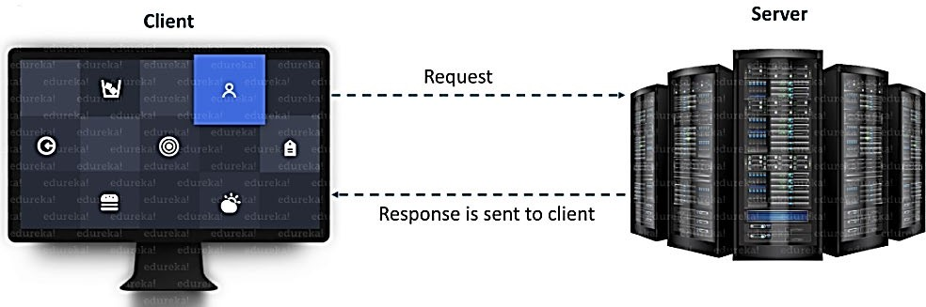

The server forms the listener socket while the client reaches out to the server. Socket and Server Socket [classes](https://www.edureka.co/blog/java-tutorial/#obj) are used for connection-oriented socket programming.

## What is a Socket in Java?

A socket in [Java](https://www.edureka.co/blog/java-tutorial/) is one endpoint of a two-way communication link between two programs running on the network. A socket is bound to a port number so that the TCP layer can identify the application that data is destined to be sent to.

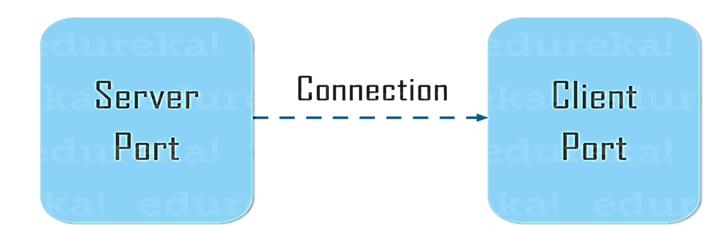

An endpoint is a combination of an IP address and a port number. The package in the Java platform provides a class, Socket that implements one side of a two-way connection between your Java program and another program on the network. The class sits on top of a platform-dependent implementation, hiding the details of any particular system from your Java program. By using the class instead of relying on native code, your [Java programs](https://www.edureka.co/blog/java-programs/) can communicate over the network in a platform- independent fashion.

## Client Side Programming

In the case of client-side programming, the client will first wait for the server to start. Once the server is up and running, it will send the requests to the server. After that, the client will wait for the response from the server. So, this is the whole logic of client and server communication. Now let’s understand the client side and server-side programming in detail.

In order to initiate a clients request, you need to follow the below-mentioned steps:

## Establish a Connection

The very first step is to establish a socket connection. A socket connection implies that the two machines have information about each other’s network location (IP Address) and TCP port.

You can create a Socket with the help of a below statement: Socket socket = new Socket(“127.0.0.1”, 5000)

* + Here, the first argument represents the IP address of Server.
  + The second argument represents the TCP Port. (It is a number that represents which application should run on a server.)

## Communication

In order to communicate over a socket connection, streams are used for both input and output the data. After establishing a connection and sending the requests, you need to close the connection.

getInputStream() – method is used to get input from the end user. getOutputStream()- method is used to send the output through the socket. readLine()- used to read a single line of text from the console.

## Closing the connection

The socket connection is closed explicitly once the message to the server is sent. input.close()- method closes the scanner class for taking the input.

out.close()- method closes the output stream. socket.close()- method closes the socket connection.

out.flush()- method flushes the stream, if the stream has saved any characters from the various write() methods in a buffer.

## Server-Side Programming

Basically, the server will instantiate its object and wait for the client request. Once the client sends the request, the server will communicate back with the response.

In order to code the server-side application, you need two sockets and they are as follows:

* A ServerSocket which waits for the client requests (when a client makes a new Socket())
* A plain old socket for communication with the client.

After this, you need to communicate with the client with the response.

## Communication

getInputStream() – method is used to get input from the end user. getOutputStream()- method is used to send the output through the socket.

## Close the Connection

It is important to close the connection by closing the socket as well as input/output streams once everything is done.

## URL Class

[Java](https://www.edureka.co/blog/what-is-java/) URL class mainly deals with URL(Uniform Resource Locator) which is used to identify the resources on the internet.

For Example: https://[www.java.co/blog](http://www.java.co/blog) Here, https: -> Protocol

[www.java.co](http://www.java.co/) -> hostname

/blog - > filename

URL Class comprises of various methods to return the URL information of a particular website.

## Various methods of Java URL Class.

1. **getProtocol() :** Returns protocol of URL
2. **getHost() :** Returns hostname(domain name) of the specified URL
3. **getPort() :** Returns port number of the URL specified
4. **getFile() :** Returns filename of the URL

## Server Program (MyServer.java)

import java.io.*; import java.net.*; public class MyServer {

public static void main(String[] args) { try {

ServerSocket ss = new ServerSocket(6666); System.out.println("Server is on..... Listening ");

Socket s = ss.accept();// establishes connection

DataInputStream dis = new DataInputStream(s.getInputStream()); String str = (String) dis.readUTF();

System.out.println("message= " + str); ss.close();

} catch (Exception e) { System.out.println(e);

}

}

}

## Client Program (MyClient.java)

import java.io.*; import java.net.*; public class MyClient {

public static void main(String[] args) { try {

Socket s = new Socket("localhost", 6666);

DataOutputStream dout = new DataOutputStream(s.getOutputStream()); dout.writeUTF("Hello Server");

dout.flush();

dout.close();

s.close();

} catch (Exception e) { System.out.println(e);

}

}

}

**Output**

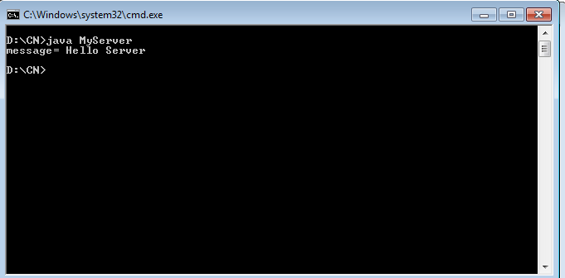

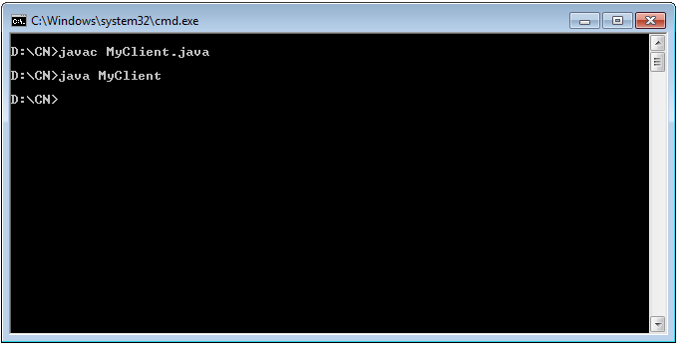

**Server Program(ECHO):**

import java.net.*; import java.io.*; public class EServer {

public static void main(String args[]) { try {

ServerSocket s = new ServerSocket(9000); String line;

Socket c = s.accept();

DataInputStream is = new DataInputStream(c.getInputStream()); PrintStream ps = new PrintStream(c.getOutputStream());

while (true) {

line = is.readLine(); ps.println(line);

}

} catch (IOException e) { System.out.println(e);

}}}

**Client Program (ECHO):**

import java.net.*; import java.io.*; public class EClient {

public static void main(String arg[]) { try {

InetAddress ia = InetAddress.getLocalHost(); Socket c = new Socket(ia, 9000);

String line;

PrintStream os = new PrintStream(c.getOutputStream()); DataInputStream is = new DataInputStream(System.in); DataInputStream is1 = new DataInputStream(c.getInputStream()); while (true) {

System.out.println("Client:"); line = is.readLine(); os.println(line);

System.out.println("Server:" + is1.readLine());

}

} catch (IOException e) { System.out.println("Socket Closed!");

}}}

**Output**

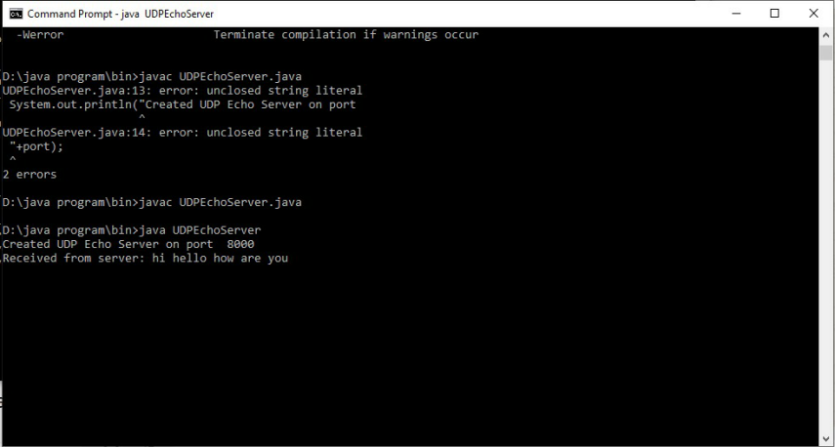

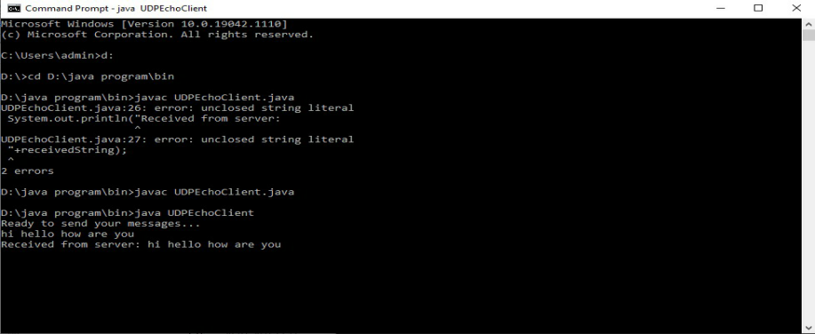

## Program Server_DT

import java.net.*; import java.io.*; import java.util.Date; public class Server_DT {

public static void main(String[] args) throws IOException { ServerSocket ss = new ServerSocket(5000);

System.out.println("The Server has reserved port No.: "+ss.getLocalPort() + " for this Service"); Socket cs = ss.accept();

System.out.println( "Client with IP Address " + cs.getInetAddress() + " has communicated via port No.: " + cs.getPort());

Date d = new Date();

String s = "Current Date & Time on Server is:" + d;

PrintWriter toclient = new PrintWriter(cs.getOutputStream(), true); toclient.print(s);

toclient.close(); cs.close();

ss.close();

}

}

## Client_DT

import java.net.*; import java.io.*; public class Client_DT {

public static void main(String[] args) throws UnknownHostException, IOException { Socket cs = new Socket("LocalHost", 5000);

System.out.println("Client " + cs.getInetAddress() + " is communicating from port No.: " + cs.getPort());

BufferedReader fromserver = new BufferedReader(new InputStreamReader(cs.getInputStream()));

System.out.println(fromserver.readLine()); fromserver.close();

cs.close();

}

}

**Output**

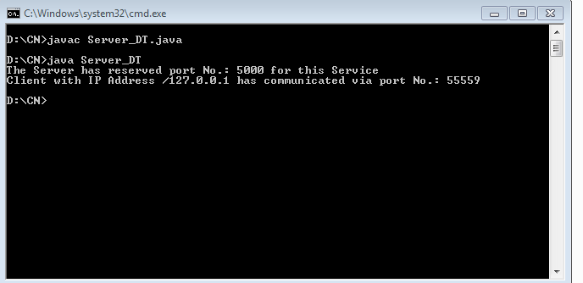

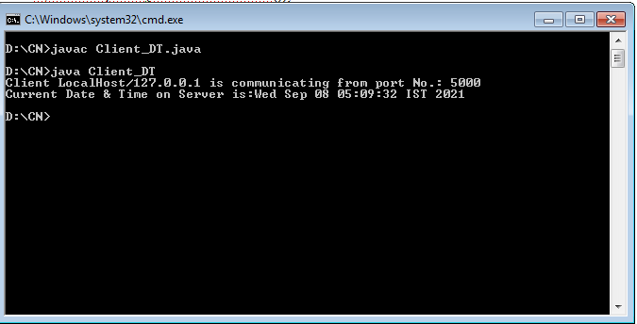

## Server

import java.io.*; import java.net.*; class Server_HalfDup {

public static void main(String args[])throws Exception { ServerSocket ss = new ServerSocket(888);

Socket s = ss.accept(); System.out.println("Connection established");

PrintStream ps = new PrintStream(s.getOutputStream()); BufferedReader br = new BufferedReader(new

InputStreamReader(s.getInputStream())); BufferedReader kb = new BufferedReader(new

InputStreamReader(System.in)); while (true) {

String str, str1;

while ((str = br.readLine()) != null) { System.out.println("From Client:" + str); str1 = kb.readLine();

ps.println(str1);

}

ps.close(); br.close(); kb.close(); ss.close(); s.close(); System.exit(0);} } }

## Client

import java.io.*; import java.net.*; class Client_HalfDup {

public static void main(String args[]) throws Exception {

Socket s = new Socket("localhost", 888);

DataOutputStream dos = new DataOutputStream(s.getOutputStream()); BufferedReader br = new BufferedReader(new

InputStreamReader(s.getInputStream())); BufferedReader kb = new BufferedReader(new

InputStreamReader(System.in)); String str, str1;

while (!(str = kb.readLine()).equals("exit")) { dos.writeBytes(str + "\n");

str1 = br.readLine(); System.out.println("From Server: "+str1); }

dos.close(); br.close(); kb.close(); s.close(); } }

**Output**

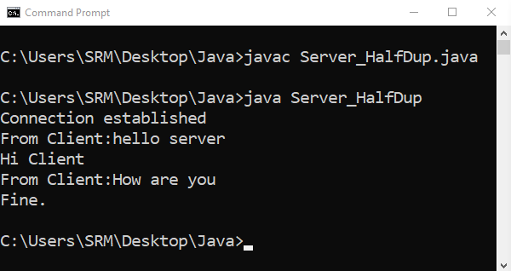

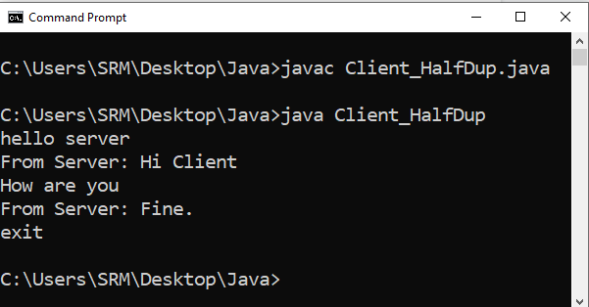

## Server

package com;

import java.io.IOException; import java.io.*;

import java.net.*; import java.util.Scanner; public class Server {

static ServerSocket serverSocket;

public static void main(String[] args) { try { serverSocket = new ServerSocket(1515);

while (true) { Socket accept_client = serverSocket.accept(); new Thread(new ServerIn(accept_client)).start();

new Thread(new ServerOut(accept_client)).start(); }

} catch (IOException e) { e.printStackTrace(); try { serverSocket.close(); } catch (IOException e1) { e1.printStackTrace(); } } } }

class ServerIn implements Runnable {

Socket socket; ServerIn(Socket socket) { this.socket = socket; } @Override

public void run() { try {

InputStream in = socket.getInputStream(); while (true) {

byte infile[] = new byte[1024]; int size = in.read(infile);

String string = new String(infile, 0, size);

if (!string.equals("") && !string.equals("\n")) System.out.println("message from client: " + string); }

} catch (IOException e) { e.printStackTrace();

try { socket.close(); } catch (IOException e1) { e1.printStackTrace(); } } } } class ServerOut implements Runnable {

Socket socket;

Scanner reader = new Scanner(System.in); ServerOut(Socket socket) { this.socket = socket; } public void run() { try {

OutputStreamWriter out = new OutputStreamWriter(socket.getOutputStream()); while (true) {

String string = reader.nextLine(); out.write(string);

out.flush(); }

} catch (IOException e) { e.printStackTrace();

try { socket.close(); reader.close();}

catch (IOException e1) { e1.printStackTrace();} } } }

## Client

package com; import java.io.*; import java.util.*; import java.net.*; public class Client {

public static void main(String[] args) {

try { Socket client = new Socket("127.0.0.1", 1515); new Thread(new ClientIn(client)).start();

new Thread(new ClientOut(client)).start();

} catch (IOException e) { e.printStackTrace(); } } } class ClientIn implements Runnable { Socket socket;

ClientIn(Socket socket) { this.socket = socket; } @Override

public void run() {

try { InputStream in = socket.getInputStream(); while (true) {

byte infile[] = new byte[1024]; int size = in.read(infile);

String string = new String(infile, 0, size);

if (!string.equals("") && !string.equals("\n")) System.out.println("message from server: " + string); }

} catch (IOException e) { e.printStackTrace(); try { socket.close();}

catch (IOException e1) { e1.printStackTrace(); } } } } class ClientOut implements Runnable {

Socket socket; Scanner reader = new Scanner(System.in); ClientOut(Socket socket) { this.socket = socket; }

public void run() { try { OutputStreamWriter out = new

OutputStreamWriter(socket.getOutputStream()); while (true) {

String string = reader.nextLine(); out.write(string); out.flush(); }

} catch (IOException e) { e.printStackTrace();

try { socket.close(); reader.close();}

catch (IOException e1) { e1.printStackTrace(); } } } }

**Output**

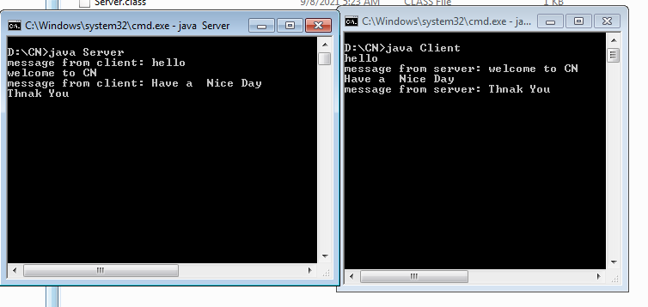

**Server**

import java.net.*;

import java.io.*;

import java.util.*;

public class FTPServer

{

public static void main(String args[]) throws Exception

{

ServerSocket soc=new ServerSocket(5217);

System.out.println("FTP Server Started on Port Number 5217");

while(true)

{

System.out.println("Waiting for Connection ...");

transferfile t=new transferfile(soc.accept());

}

}

}

class transferfile extends Thread

{

Socket ClientSoc;

DataInputStream din;

DataOutputStream dout;

transferfile(Socket soc)

{

try

{

ClientSoc=soc;

din=new DataInputStream(ClientSoc.getInputStream());

dout=new DataOutputStream(ClientSoc.getOutputStream());

System.out.println("FTP Client Connected ...");

start();

}

catch(Exception ex)

{

}}

void SendFile() throws Exception

{

String filename=din.readUTF();

File f=new File(filename);

if(!f.exists())

{

dout.writeUTF("File Not Found");

return;

}

else

{

dout.writeUTF("READY");

FileInputStream fin=new FileInputStream(f);

int ch;

do

{

ch=fin.read();

dout.writeUTF(String.valueOf(ch));

}

while(ch!=-1);

fin.close();

dout.writeUTF("File Receive Successfully");

}

}

void ReceiveFile() throws Exception

{

String filename=din.readUTF();

if(filename.compareTo("File not found")==0)

{

return;

}

File f=new File(filename);

String option;

if(f.exists())

{

dout.writeUTF("File Already Exists");

option=din.readUTF();

}

else

{

dout.writeUTF("SendFile");

option="Y";}

if(option.compareTo("Y")==0)

{

FileOutputStream fout=new FileOutputStream(f);

int ch;

String temp;

do

{

temp=din.readUTF();

ch=Integer.parseInt(temp);

if(ch!=-1)

{

fout.write(ch);

}

}while(ch!=-1);

fout.close();

dout.writeUTF("File Send Successfully");

}

else

{

return;

}

}

public void run()

{

while(true)

{

try

{

System.out.println("Waiting for Command ...");

String Command=din.readUTF();

if(Command.compareTo("GET")==0)

{

System.out.println("\tGET Command Received ...");

SendFile();

continue;

}

else if(Command.compareTo("SEND")==0)

{

System.out.println("\tSEND Command Received ...");

ReceiveFile();

continue;

}

else if(Command.compareTo("DISCONNECT")==0)

{

System.out.println("\tDisconnect Command Received ...");

System.exit(1);

}

}

catch (Exception ex){

}}}

**Client**

import java.net.*;

import java.io.*;

import java.util.*;

class FTPClient

{

public static void main(String args[]) throws Exception

{

Socket soc=new Socket("127.0.0.1",5217);

transferfileClient t=new transferfileClient(soc);

t.displayMenu();

}

}

class transferfileClient

{

Socket ClientSoc;

DataInputStream din;

DataOutputStream dout;

BufferedReader br;

transferfileClient(Socket soc)

{

try

{

ClientSoc=soc;

din=new DataInputStream(ClientSoc.getInputStream());

dout=new DataOutputStream(ClientSoc.getOutputStream());

br=new BufferedReader(new InputStreamReader(System.in));

}

catch(Exception ex){

}}

void SendFile() throws Exception

{

String filename;

System.out.print("Enter File Name :");

filename=br.readLine();

File f=new File(filename);

if(!f.exists())

{

System.out.println("File not Exists...");

dout.writeUTF("File not found");

return;

}

dout.writeUTF(filename);

String msgFromServer=din.readUTF();

if(msgFromServer.compareTo("File Already Exists")==0)

{

String Option;

System.out.println("File Already Exists. Want to OverWrite (Y/N) ?");

Option=br.readLine();

if(Option=="Y")

{

dout.writeUTF("Y");

}

else

{

dout.writeUTF("N");

return;

}

}

System.out.println("Sending File ...");

FileInputStream fin=new FileInputStream(f);

int ch;

do

{

ch=fin.read();

dout.writeUTF(String.valueOf(ch));

}

while(ch!=-1);

fin.close();

System.out.println(din.readUTF());

}

void ReceiveFile() throws Exception

{

String fileName;

System.out.print("Enter File Name :");

fileName=br.readLine();

dout.writeUTF(fileName);

String msgFromServer=din.readUTF();

if(msgFromServer.compareTo("File Not Found")==0)

{

System.out.println("File not found on Server ...");

return;

}

else if(msgFromServer.compareTo("READY")==0)

{

System.out.println("Receiving File ...");

File f=new File(fileName);

if(f.exists())

{

String Option;

System.out.println("File Already Exists. Want to OverWrite (Y/N) ?");

Option=br.readLine();

if(Option=="N")

{

dout.flush();

return;

}

}

FileOutputStream fout=new FileOutputStream(f);

int ch;

String temp;

do

{

temp=din.readUTF();

ch=Integer.parseInt(temp);

if(ch!=-1)

{

fout.write(ch);

}

}

while(ch!=-1);

fout.close();

System.out.println(din.readUTF());

}

}

public void displayMenu() throws Exception

{

while(true)

{

System.out.println("[ MENU ]");

System.out.println("1. Send File");

System.out.println("2. Receive File");

System.out.println("3. Exit");

System.out.print("\nEnter Choice :");

int choice;

choice=Integer.parseInt(br.readLine());

if(choice==1)

{

dout.writeUTF("SEND");

SendFile();

}

else if(choice==2)

{

dout.writeUTF("GET");

ReceiveFile();

}

else

{

dout.writeUTF("DISCONNECT");

System.exit(1);

}

}

}

}

**OUTPUT**

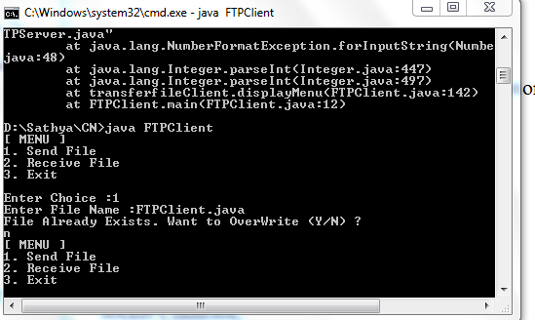

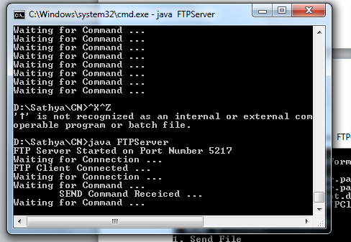

## Server

import java.io.*; import java.net.*;

class RemoteServer {

public static void main(String args[]) { try {

int Port;

BufferedReader Buf = new BufferedReader(new InputStreamReader(System.in));

System.out.print(" Enter the Port Address : "); Port = Integer.parseInt(Buf.readLine()); ServerSocket ss = new ServerSocket(Port);

System.out.println(" Server is Ready To Receive a Command. "); System.out.println(" Waiting ");

Socket s = ss.accept();

if (s.isConnected() == true)

System.out.println(" Client Socket is Connected Successfully. "); InputStream in = s.getInputStream();

OutputStream ou = s.getOutputStream();

BufferedReader buf = new BufferedReader(new InputStreamReader(in)); String command = buf.readLine();

PrintWriter pr = new PrintWriter(ou); pr.println(command);

Runtime H = Runtime.getRuntime(); Process P = H.exec(command);

System.out.println(" The " + command + " Command is Executed Successfully. ");

pr.flush();

pr.close();

ou.close();

in.close();

} catch (Exception e) {

System.out.println(" Error : " + e.getMessage());

}

}

}

## Client

import java.io.*; import java.net.*;

class RemoteClient {

public static void main(String args[]) { try {

int Port;

BufferedReader Buf = new BufferedReader(new InputStreamReader(System.in));

System.out.print(" Enter the Port Address : "); Port = Integer.parseInt(Buf.readLine()); Socket s = new Socket("localhost", Port);

if (s.isConnected() == true)

System.out.println(" Server Socket is Connected Successfully. "); InputStream in = s.getInputStream();

OutputStream ou = s.getOutputStream(); BufferedReader buf = new BufferedReader(new

InputStreamReader(System.in));

BufferedReader buf1 = new BufferedReader(new InputStreamReader(in)); PrintWriter pr = new PrintWriter(ou);

System.out.print(" Enter the Command to be Executed : "); pr.println(buf.readLine());

pr.flush();

String str = buf1.readLine();

System.out.println(" " + str + " Opened Successfully. "); System.out.println(" The " + str + " Command is Executed Successfully. "); pr.close();

ou.close();

in.close();

} catch (Exception e) {

System.out.println(" Error : " + e.getMessage());

}

}

}

**OUTPUT**

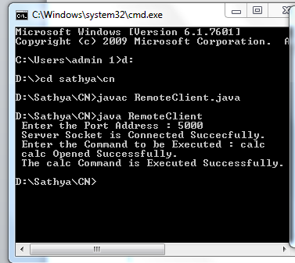

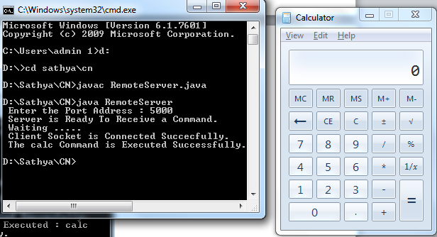

## Server

import java.io.*; import java.net.*; import java.util.*;

class Serverarp12 {

public static void main(String args[]) { try {

DatagramSocket server = new DatagramSocket(1309); while (true) {

byte[] sendbyte = new byte[1024]; byte[] receivebyte = new byte[1024];

DatagramPacket receiver = new DatagramPacket(receivebyte, receivebyte.length);

server.receive(receiver);

String str = new String(receiver.getData()); String s = str.trim();

// System.out.println(s);

InetAddress addr = receiver.getAddress(); int port = receiver.getPort();

String ip[] = { "165.165.80.80", "165.165.79.1" };

String mac[] = { "6A:08:AA:C2", "8A:BC:E3:FA" };

for (int i = 0; i < ip.length; i++) { if (s.equals(ip[i])) {

sendbyte = mac[i].getBytes();

DatagramPacket sender = new DatagramPacket(sendbyte, sendbyte.length, addr, port);

server.send(sender); break;

}

}

break;

}

} catch (Exception e) { System.out.println(e);

}

}

}

## Client

import java.io.*; import java.net.*; import java.util.*;

class Clientarp12 {

public static void main(String args[]) { try {

DatagramSocket client = new DatagramSocket(); InetAddress addr = InetAddress.getByName("127.0.0.1"); byte[] sendbyte = new byte[1024];

byte[] receivebyte = new byte[1024]; BufferedReader in = new BufferedReader(new

InputStreamReader(System.in));

System.out.println("Enter the logical address (IP):"); String str = in.readLine();

sendbyte = str.getBytes();

DatagramPacket sender = new DatagramPacket(sendbyte, sendbyte.length, addr, 1309);

client.send(sender);

DatagramPacket receiver = new DatagramPacket(receivebyte, receivebyte.length);

client.receive(receiver);

String s = new String(receiver.getData()); System.out.println("The Physical Address is: " + s.trim()); client.close();

} catch (Exception e) { System.out.println(e);

}

}

}

**Output:**

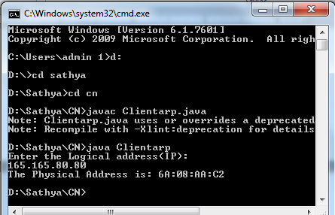

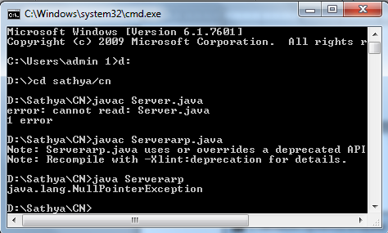

|  |  |
| --- | --- |
| **Ex No: 11** | **STUDY OF IPV6 ADDRESSING AND SUBNETTING** |
| **Date:** |

# PROCEDURE:

## IPv6 Address Terminology Node

Any device that runs an implementation of IPv6. This includes routers and hosts.

## Router

A node that can forward IPv6 packets not explicitly addressed to itself. On an IPv6 network, a router also typically advertises its presence and host configuration information.

## Host

A node that cannot forward IPv6 packets not explicitly addressed to itself (a non- router). A host is typically the source and a destination of IPv6 traffic, and it silently discards traffic received that is not explicitly addressed to itself.

## Upper-layer protocol

A protocol above IPv6 that uses IPv6 as its transport. Examples include Internet layer protocols such as ICMPv6 and Transport layer protocols such as TCP and UDP (but not Application layer protocols such as FTP and DNS, which use TCP and UDP as their transport).

## Link

The set of network interfaces that are bounded by routers and that use the same 64-bit IPv6unicast address prefix. Other terms for “link” are subnet and network segment.

## Network

Two or more subnets connected by routers. Another term for networks is internetworks.

## Neighbors

Nodes connected to the same link. Neighbors in IPv6 have special significance because of IPv6Neighbor Discovery, which has facilities to resolve neighbor link layer addresses and detect and monitor neighbor reach ability

## Interface

The representation of a physical or logical attachment of a node to a link. An example of a physical interface is a network adapter. An example of a logical interface is a “tunnel” interface that is used to send IPv6 packets across an IPv4 network by encapsulating the IPv6 packet inside an IPv4header.

## Address

An identifier that can be used as the source or destination of IPv6 packets that is assigned at the IPv6layer to an interface or set of interfaces.

## Packet

The protocol data unit (PDU) that exists at the IPv6 layer and is composed of an IPv6 header and payload.

## Link

MTU The maximum transmission unit (MTU)—the number of bytes in the largest IPv6packet—that can be sent on a link. Because the maximum frame size includes the link-layer medium headers and trailers, the link MTU is not the same as the maximum frame size of the link. The linkMTU is the same as the maximum payload size of the link-layer technology. For example, for Ethernet Using Ethernet II encapsulation, the maximum Ethernet frame payload size is 1500 bytes. Therefore,the link MTU is 1500. For a link with multiple link-layer technologies (for example, a bridged link),the link MTU is the smallest link MTU of all the link-layer technologies present on the link.

## Path

MTU The maximum-sized IPv6 packet that can be sent without performing host fragmentation between a source and destination over a path in an IPv6 network. The path MTU is typically the smallest link MTU of all the links in the path.

## IPv6 Address Format

Whereas IPv4 addresses use a dotted-decimal format, where each byte ranges from 0 to255.IPv6 addresses use eight sets of four hexadecimal addresses (16 bits in each set), separated by a colon (:),like this: xxxx:xxxx:xxxx:xxxx:xxxx:xxxx:xxxx:xxxx (x would be a hexadecimal value). This Notation is commonly called string notation.

Hexadecimal values can be displayed in either lower- or upper-case for the numbers A–F..A leading zero in a set of numbers can be omitted; for example, you could either enter 0012 or 12 in one of the eight fields—both are correct. If you have successive fields of zeroes in an IPv6 address, you can represent them as two colons (::). For example, 0:0:0:0:0:0:0:5 could be represented as ::5; andABC:567:0:0:8888:9999:1111:0 could be represented as ABC:567::8888:9999:1111:0. However, you can only do this once in the address: ABC::567::891::00 would be invalid since :: appears more than once in the address. The reason for this limitation is that if you had two or more repetitions, you wouldn't know how many sets of zeros were being omitted from each part. An unspecified address is represented as ::, since it contains all zeros.

## Types of IPv6 Addresses

**Anycast**

An anycast address identifies one or more interfaces. Notice that the term device isn’t used since a device can have more than one interface. Sometimes people use the term node to designate an interface on a device. Basically, an anycast is a hybrid of a unicast and multicast address.

* With a unicast, one packet is sent to one destination;
* With a multicast, one packet is sent to all members of the multicast group;
* With an anycast, a packet is sent to any one member of a group of devices that are configured with the anycast address. By default, packets sent to an anycast address are forwarded to the closest interface (node), which is based on the routing

process employed to get the packet to the destination. Given this process, anycast addresses are commonly referred to as one-to-the-nearest addresses.

## Multicast

Represent a group of interfaces interested in seeing the same traffic.

* The first 8 bits are set to FF.
* The next 4 bits are the lifetime of the address: 0 is permanent and 1 is temporary.
* The next 4 bits indicate the scope of the multicast address (how far the packet can travel):

1 is for a node, 2 is for a link, 5 is for the site, 8 is for the organization, and E is global(the Internet).

## Unicast

The following types of addresses are unicast IPv6 addresses:

* Global unicast addresses
* Link-local addresses
* Site-local addresses
* Unique local addresses
* Special addresses
* Transition addresses

## Global Unicast Addresses

IPv6 global addresses are equivalent to public IPv4 addresses. They are globally routable and reachable on the IPv6 Internet. Global unicast addresses are designed to be aggregated or summarized for an efficient routing infrastructure. Unlike the current IPv4-based Internet, which is a mixture of both flat and hierarchical routing, the IPv6-based Internet has been designed from its foundation to support efficient, hierarchical addressing and routing. The scope of a global address is the entire IPv6Internet. RFC 4291 defines global addresses as all addresses that are not the unspecified, loopback,link-local unicast, or multicast addresses. However, Figure shows the structure of global unicast addresses defined in RFC 3587 that are currently being used on the IPv6 Internet. The structure of global unicast addresses defined in RFC 3587. The fields in the global unicast address are described in the following list:

Global Routing Prefix Indicates the global routing prefix for a specific organization’s site. The Combination of the three fixed bits and the 45-bit Global Routing Prefix is used to create a 48-bit site prefix, which is assigned to an individual site of an organization. A site is an autonomously operatingIP-based network that is connected to the IPv6 Internet. Network architects and administrators within the site determine the addressing plan and routing policy for the organization network. Once assigned,routers on the IPv6 Internet forward IPv6 traffic matching the 48-bit prefix to the routers of the organization's site.

Subnet ID The Subnet ID is used within an organization’s site to identify subnets within its site. The Size of this field is 16 bits. The organization’s site can use these 16 bits within its site to create 65,536subnets or multiple levels of addressing hierarchy and an efficient routing infrastructure. With 16 bits in subnetting flexibility, a global unicast prefix assigned to an organization site is equivalent to a publicIPv4 Class A address prefix (assuming that the last octet is used for identifying nodes on subnets). Therouting structure of the organization’s network is not visible to the ISP.Interface ID Indicates the interface on a specific subnet within the site. The size of this field is 64 bits. The interface ID in IPv6is equivalent to the node ID or host ID in IPv4.

## Local-Use Unicast Addresses

Local-use unicast addresses do not have a global scope and can be reused. There are two types of local-use unicast addresses: Link-local addresses are used between on-link neighbors and forNeighbor Discovery processes. Site-local addresses are used between nodes communicating with other nodes in the same organization.

## Link-Local Addresses FE8:: through FEB::

Link-local addresses are a new concept in IPv6. These kinds of addresses have a smaller scope as to how far they can travel: just the local link (the data link layer link). Routers will process packets destined to a link-local address, but they will not forward them to other links. Their most common uses for a device to acquire unicast site-local or global unicast addressing information, discovering the default gateway, and discovering other layer 2 neighbors on the segment. IPv6 link-local addresses identified by the initial 10 bits being set to 1111 1110 10 and the next 54 bits set to 0, are used by nodes when communicating with neighboring nodes on the same link.

For example, on a single-link IPv6network with no router, link-local addresses are used to communicate between hosts on the link. IPv6link-local addresses are similar to IPv4 link-local addresses defined in RFC 3927 that use the169.254.0.0/16 prefix. The use of IPv4 link-local addresses is known as Automatic Private IPAddressing (APIPA) in Windows Vista, Windows Server 2008, Windows Server 2003, and WindowsXP. The scope of a link local address is the local link. A link-local address is required for someNeighbor Discovery processes and is always automatically configured, even in the absence of all other unicast addresses. Link-local addresses always begin with FE80. With the 64-bit interface identifier,the prefix for link-local addresses is always FE80::/64.

## Site-Local Addresses FEC:: through FFF::

It represents a particular site or company. These addresses can be used within a company without having to waste any public IP addresses—not that this is a concern, given the large number of addresses available in IPv6. However, by using private addresses, you can easily control who is allowed to leave your network and get returning traffic back by setting up address translation policies for IPv6.

Site-local addresses, identified by setting the first 10 bits to 1111 1110 11, are equivalent to the IPv4private address space (10.0.0.0/8, 172.16.0.0/12, and 192.168.0.0/16). For example, private intranets that do not have a direct, routed connection to the IPv6 Internet can use site local addresses conflicting with global addresses. Site-local addresses are not reachable from other sites, and routers must not forward site-local traffic outside the site. Site-local addresses can be used in addition to globaladdresses. The scope of a site-local address is the site. Unlike link- local addresses, site-local addresses are not automatically configured and must be assigned either through stateless or stateful address autoconfiguration. The first 10 bits are always fixed for site-local addresses, beginning with FEC0::/10.After the 10 fixed bits is a 54-bit Subnet ID field that provides 54 bits with which you can create subnets within your organization. You can have a flat subnet structure, or you can divide the high order bits of the Subnet ID field to create a hierarchical and summarized routing infrastructure. After the SubnetID field is a 64-bit Interface ID field that identifies a specific interface on a subnet. Site-local addresses have been

formally deprecated in RFC 3879 for future IPv6 implementations. However, existing implementations of IPv6 can continue to use site-local addresses.

## Zone IDs for Local-Use Addresses

Unlike global addresses, local-use addresses (link-local and site-local addresses) can be reused.Link-local addresses are reused on each link. Site-local addresses can be reused within each site of an organization. Because of this address reuse capability, link-local and site-local addresses are ambiguous. To specify the link on which the destination is located or the site within which the destination is located, an additional identifier is needed. This additional identifier is a zone identifier(ID), also known as a scope ID, which identifies a connected portion of a network that has a specified scope. The syntax specified in RFC 4007 for identifying the zone associated with a local-use addressis Address%zone ID, in which Address is a local-use unicast IPv6 address and zone ID is an integer value representing the zone. The values of the zone ID are defined relative to the sending host.

Therefore, different hosts might determine different zone ID values for the same physical zone. For Example, Host A might choose 3 to represent the zone of an attached link and Host B might choose 4to represent the same link.

## Unique Local Addresses

Site-local addresses provide a private addressing alternative to global addresses for internet traffic. However, because the site-local address prefix can be reused to address multiple sites within an organization, a site-local address prefix can be duplicated. The ambiguity of site local addresses in an organization adds complexity and difficulty for applications, routers, and network managers

To replace site-local addresses with a new type of address that is private to an organization yet unique across all the sites of the organization, RFC 4193 defines unique local IPv6 unicast addresses.

The first 7 bits have the fixed binary value of 1111110. All local addresses have the address prefixFC00::/7. The Local (L) flag is set 1 to indicate that the prefix is locally assigned. The L flag value set to 0 is not defined in RFC 3879. Therefore, unique local addresses within an organization with the Lflag set to 1 have the address prefix of

FD00::/8. The Global ID identifies a specific site within an organization and is set to a randomly derived 40-bit value. By deriving a random value for the GlobalID, an organization can have statistically unique 48-bit prefixes assigned to their sites. Additionally,two organizations that use unique local addresses that merge have a low probability of duplicating a48-bit unique local address prefix, minimizing site renumbering. Unlike the Global Routing Prefix in global addresses, the Global IDs in unique local address prefixes are not designed to be summarized.

## The following are the special IPv6 addresses:

**Unspecified address**

The unspecified address (0:0:0:0:0:0:0:0 or ::) is used only to indicate the absence of an address. It is equivalent to the IPv4 unspecified address of 0.0.0.0. The unspecified address is typically used as a source address when a unique address has not yet been determined. The unspecified address is neverassigned to an interface or used as a destination address.

## Loopback address

The loopback address (0:0:0:0:0:0:0:1 or ::1) is assigned to a loopback interface, enabling a node to send packets to itself. It is equivalent to the IPv4 loopback address of 127.0.0.1. Packets addressed to the loopback address must never be sent on a link or forwarded by an IPv6 router.

## Transition Addresses

To aid in the transition from IPv4 to IPv6 and the coexistence of both types of hosts, the following addresses are defined:

## IPv4-compatible address

The IPv4-compatible address, 0:0:0:0:0:0:w.x.y.z or ::w.x.y.z (where w.x.y.z is the dotted decimal representation of a public IPv4 address), is used by IPv6/IPv4 nodes that are communicating with IPv6over an IPv4 infrastructure that uses public IPv4 addresses, such as the Internet. IPv4-compatible addresses are deprecated in RFC 4291 and are not supported in IPv6 for Windows Vista and WindowsServer 2008.

## IPv4-mapped address

The IPv4-mapped address, 0:0:0:0:0:FFFF:w.x.y.z or ::FFFF: w.x.y.z, is used to represent an IPv4address as a 128-bit IPv6 address.

## ISATAP address

An address of the type 64-bit prefix:0:5EFE:w.x.y.z, where w.x.y.z is a private IPv4 address, is assignedto a node for the Intra-Site Automatic Tunnel Addressing Protocol (ISATAP) IPv6 transition technology.

## Teredo address

A global address that uses the prefix 2001::/32 and is assigned to a node for the Teredo IPv6 transition technology. Beyond the first 32 bits, Teredo addresses are used to encode the IPv4 address of a Teredo Server, flags, and an obscured version of a Teredo client’s external address and UDP port number.

## Assigning IPv6 address to Devices

**IPv6 Addresses for a Host**

An IPv4 host with a single network adapter typically has a single IPv4 address assigned to that adapter.An IPv6 host, however, usually has multiple IPv6 addresses assigned to each adapter. The interfaces on a typical IPv6 host are assigned the following unicast addresses:

## A link-local address for each interface

Additional unicast addresses for each interface (which could be one or multiple unique local or global addresses)

* The loopback address (::1) for the loopback interface: Typical IPv6 hosts are always logically multi homed because they always have at least two addresses with which they can receive packets—a link-local address for local link traffic and a routable unique local or global address.

Additionally, each interface on an IPv6 host is listening for traffic on the following multicast addresses:

* The interface-local scope all-nodes multicast address (FF01::1)
* The link-local scope all-nodes multicast address (FF02::1)
* The solicited-node address for each unicast address assigned
* The multicast addresses of joined groups

# SUBNETTING

A subnetwork or subnet is a logical subdivision of an IP network. The practice of dividing a network into two or more networks is called subnetting. Computers that belong to a subnet are addressed with an identical most-significant bit-group in their IP addresses.

## Advantage of Subnetting

* Subnetting allows us to break a single large network in smaller networks. Small Networks are easy to manage.
* Subnetting reduces network traffic by allowing only the broadcast traffic which is relevant to the subnet.
* By reducing unnecessary traffic, Subnetting improves overall performance of the network.
* By blocking a subnet’ traffic in the subnet, Subnetting increases security of the network.
* Subnetting reduces the requirement of IP range.

## Disadvantage of Subnetting

* Different subnets need an intermediate device known as router to communicate with each otherSince each subnet uses its own network address and broadcast address, more subnetsmean more wastage of IP addresses.
* Subnetting adds complexity in the network. An experienced network administrator is required to manage the subnetted network.

## Class A Subnets

In Class A, only the first octet is used as Network identifier and the rest of three octets are used to be assigned to Hosts (i.e. 16777214 Hosts per Network). To make more subnet in Class A, bits fromHost part are borrowed and the subnet mask is changed accordingly.For example, if one MSB (Most Significant Bit) is borrowed from host bits of second octet and added to Network address, it creates two Subnets (21=2) with (223-2) 8388606 Hosts per Subnet.

## Class B Subnets

By default, using Classful Networking, 14 bits are used as Network bits providing (214) 16384Networks and (216-2) 65534 Hosts. Class B IP Addresses can be subnetted the same way as Class Aaddresses, by borrowing bits from Host bits.

## Class C Subnets

Class C IP addresses are normally assigned to a very small size network because it can only have 254 hosts in a network.

# PROGRAM:

import java.net.*; import java.io.*; import java.util.*;

import java.net.InetAddress;

public class JavaProgram {

public static void main(String args[]) throws Exception { InetAddress localhost = InetAddress.getLocalHost(); System.out.println("System IP Address : " +

(localhost.getHostAddress()).trim()); String systemipaddress = "";

try {

URL url_name = new URL("[http://bot.whatismyipaddress.com](http://bot.whatismyipaddress.com/)"); BufferedReader sc = new BufferedReader(new

InputStreamReader(url_name.openStream())); systemipaddress = sc.readLine().trim();

} catch (Exception e) {

systemipaddress = "Cannot Execute Properly";

}

System.out.println("Public IP Address: " + systemipaddress + "\n");

}

}

**Output:**

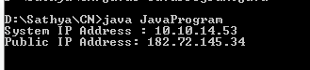

# PROGRAM (VPN):

import java.util.*; import java.net.*; import java.io.*; import java.sql.*;

public class UDP_VPN {

static String encode(String[] array) { StringBuilder output = new StringBuilder();

for (String i : array) { output.append((i.length() + 1) + "-" + i);} return output.toString();}

static String[] decode(String encoded) { StringBuilder en = new StringBuilder(encoded);

ArrayList<String> output = new ArrayList<String>(); int len, i; for (i = 0, len = 0; en.length() != 0; ++i, len = 0) {

while (Character.isDigit(en.charAt(0))) {

len = len * 10 + Integer.parseInt(en.charAt(0) + ""); en.deleteCharAt(0);}

output.add(en.substring(1, len)); en.delete(0, len); } return output.toArray(new String[0]); }

public static void main(String[] args) { System.out.println();

Scanner sc = new Scanner(System.in); String inMsg = "", outMsg = "";

String secretAuthenticationKey = "AbraKaDabra", validAuthenticationRespnse = "readyToUse";

byte[] inData, outData; InetAddress clientAddress, serverAddress;

int clientPort, serverPort, vpnPublicPort = 3333, vpnPrivatePort = 5555; String[] clientRequest, responseToClient = new String[3];

boolean validUser = false;

String vpnPublicIP = "", vpnPrivateIP = ""; try {

vpnPublicIP = InetAddress.getLocalHost().getHostAddress(); vpnPrivateIP = InetAddress.getLocalHost().getHostAddress();

} catch (Exception e) { e.printStackTrace(); } try {

DatagramSocket ds = new DatagramSocket(vpnPublicPort); DatagramPacket dsp, drp; inData = new byte[1024];

drp = new DatagramPacket(inData, inData.length); ds.receive(drp);

clientAddress = drp.getAddress(); clientPort = drp.getPort();

inMsg = new String(drp.getData(), 0, drp.getLength()); clientRequest = decode(inMsg);

System.out.println("Client msg : " + Arrays.toString(clientRequest)); if (clientRequest[2].equals(secretAuthenticationKey)) { responseToClient[0] = vpnPrivateIP;// private ip address of vpn responseToClient[1] = vpnPrivatePort + "";

responseToClient[2] = validAuthenticationRespnse; validUser = true;

System.out.println("Client Authenticated\n");

} else {

responseToClient[0] = vpnPrivateIP; responseToClient[1] = vpnPublicPort + ""; responseToClient[2] = "requestDenied"; validUser = false; System.out.println("Unauthorized client"); } outMsg = encode(responseToClient); outData = new byte[1024];

outData = outMsg.getBytes();

dsp = new DatagramPacket(outData, outData.length, clientAddress, clientPort); ds.send(dsp); ds.close();

} catch (Exception e) { System.out.println(e.toString()); } if (validUser) { try {

DatagramSocket ds = new DatagramSocket(vpnPrivatePort); try { DatagramPacket dsp, drp;

do { inData = new byte[1024];

drp = new DatagramPacket(inData, inData.length);

ds.receive(drp);

clientAddress = drp.getAddress(); clientPort = drp.getPort();

inMsg = new String(drp.getData(), 0, drp.getLength()); clientRequest = decode(inMsg);

System.out.println("Clientmsg: " + Arrays.toString(clientRequest)); serverAddress = InetAddress.getByName(clientRequest[0]); serverPort = Integer.parseInt(clientRequest[1]);

outMsg = clientRequest[2]; outData = new byte[1024]; outData = outMsg.getBytes();

dsp=newDatagramPacket(outData,outData.length, serverAddress, serverPort); ds.send(dsp);

if (outMsg.equalsIgnoreCase("bye")) { break; } inData = new byte[1024];

drp = new DatagramPacket(inData, inData.length); ds.receive(drp); serverAddress = drp.getAddress(); serverPort = drp.getPort();

inMsg = new String(drp.getData(), 0, drp.getLength()); responseToClient[0] = serverAddress.getHostAddress(); responseToClient[1] = serverPort + ""; responseToClient[2]=inMsg; System.out.println("Servermsg:"+Arrays.toString(responseToClient)); outMsg = encode(responseToClient);

outData = new byte[1024]; outData = outMsg.getBytes();

dsp=newDatagramPacket(outData,outData.length,clientAddress, clientPort); ds.send(dsp);

} while (!inMsg.equalsIgnoreCase("bye") && validUser); ds.close();

} catch (Exception e) { System.out.println(e.toString());

} finally { ds.close(); System.out.println();}}

catch (Exception e) {e.printStackTrace();}}}}

## PROGRAM (Client Side):

import java.util.*; import java.net.*; import java.io.*;

public class UDPClient {

static String encode(String[] array) { StringBuilder output = new StringBuilder();

for (String i : array) { output.append((i.length() + 1) + "-" + i); } return output.toString();}

static String[] decode(String encoded) { StringBuilder en = new StringBuilder(encoded); ArrayList<String> output = new ArrayList<String>(); int len, i;

for (i = 0, len = 0; en.length() != 0; ++i, len = 0) { while (Character.isDigit(en.charAt(0))) {

len = len * 10 + Integer.parseInt(en.charAt(0) + ""); en.deleteCharAt(0); }

output.add(en.substring(1, len)); en.delete(0, len); } return output.toArray(new String[0]); }

public static void main(String[] args) { System.out.println();

String inMsg = "", outMsg = "";

int format = 3, serverPort, vpnPublicPort = 3333, vpnPrivatePort; boolean vpnConnect = false;

String vpnPublicIP = "", serverIP, vpnPrivateIP;

String secretAuthenticationKey = "AbraKaDabra", validAuthenticationRespnse = "readyToUse";

String[] authentication = new String[format], vpnDetails = new String[format], vpnResponse, server;

Scanner sc = new Scanner(System.in); byte[] inData, outData; try {

vpnPublicIP = InetAddress.getLocalHost().getHostAddress(); DatagramSocket ds = new DatagramSocket(); DatagramPacket dsp, drp; authentication[0] = vpnPublicIP; authentication[1] = "" + vpnPublicPort;

authentication[2] = secretAuthenticationKey; outMsg = encode(authentication); outData = outMsg.getBytes(); dsp=newDatagramPacket(outData,outData.length, InetAddress.getByName(vpnPublicIP), vpnPublicPort); ds.send(dsp);

System.out.println("asking for authentication from vpn " + secretAuthenticationKey); inData = new byte[1024]; drp = new DatagramPacket(inData, inData.length); ds.receive(drp); inMsg = new String(drp.getData(), 0, drp.getLength());

vpnDetails = decode(inMsg);

if (vpnDetails[2].equals(validAuthenticationRespnse)) { vpnConnect = true;

vpnPrivateIP = InetAddress.getLocalHost().getHostAddress(); vpnPrivatePort = Integer.parseInt(vpnDetails[1]); System.out.println("Connection is established with vpn"); System.out.println("VPN Details : " + Arrays.toString(vpnDetails));

} else { System.out.println("Connection refused by vpn " + Arrays.toString(vpnDetails));

System.out.println(); }

} catch (Exception e) { e.printStackTrace(); } if (vpnConnect == true) { System.out.print("Enter Initial Server IP : "); serverIP = sc.next();

System.out.print("Enter Initial server Port : "); serverPort = sc.nextInt(); sc.nextLine(); System.out.println();

server = new String[] { serverIP, "" + serverPort, "" }; try { DatagramSocket ds = new DatagramSocket(); DatagramPacket dsp, drp;

do {

System.out.print("Enter something : ");

server[2] = sc.nextLine(); outMsg = encode(server); outData = outMsg.getBytes(); dsp=newDatagramPacket(outData,outData.length,

InetAddress.getByName(vpnDetails[0]),Integer.parseInt(vpnDetails[1])); ds.send(dsp);

if (server[2].equalsIgnoreCase("bye")) { break; } inData = new byte[1024];

drp = new DatagramPacket(inData, inData.length); ds.receive(drp);

inMsg = new String(drp.getData(), 0, drp.getLength()); vpnResponse = decode(inMsg); System.out.println("Server msg : " + vpnResponse[2]);

} while (!vpnResponse[2].equalsIgnoreCase("bye") && vpnConnect); ds.close();

} catch (Exception e) { System.out.println(e.toString()); } } } }

## PROGRAM (Server Side):

import java.util.*; import java.net.*; import java.io.*;

public class UDPServer {

public static void main(String[] args) { System.out.println();

Scanner sc = new Scanner(System.in); String inMsg = "", outMsg = "";

byte[] inData, outData; InetAddress clientAddress; int clientPort;

try { DatagramSocket ds = new DatagramSocket(8581); try {

System.out.println("Server IP : " + InetAddress.getLocalHost().getHostAddress()); System.out.println("Server Port : " + ds.getLocalPort()); DatagramPacket dsp, drp; do {

inData = new byte[1024];

drp = new DatagramPacket(inData, inData.length); ds.receive(drp);

clientAddress = drp.getAddress(); clientPort = drp.getPort();

inMsg = new String(drp.getData(), 0, drp.getLength());

System.out.println("Client msg : " + inMsg);

if (inMsg.equalsIgnoreCase("bye")) {break;} System.out.print("Enter something :"); outMsg = sc.nextLine();

outData = new byte[1024]; outData = outMsg.getBytes();

dsp = new DatagramPacket(outData, outData.length, clientAddress, clientPort); ds.send(dsp);

} while (!outMsg.equalsIgnoreCase("bye")); ds.close();

} catch (Exception e) { System.out.println(e.toString()); System.out.println();

} finally { ds.close(); }} catch (Exception e) {}}}

**OUTPUT:**

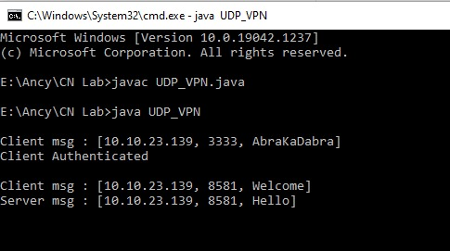

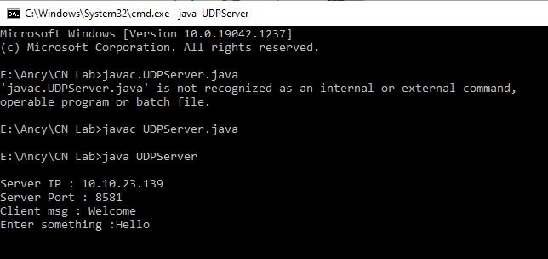

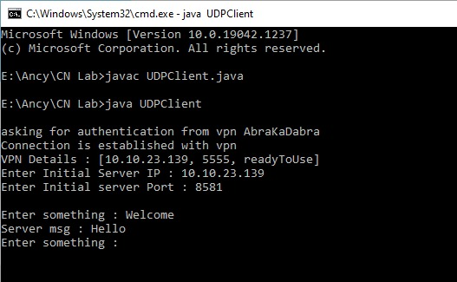

|  |  |
| --- | --- |
| **Ex No:** |  |
| **Date:** |

## PROGRAM

set ns [new Simulator] #Tell the simulator to use dynamic routing

$ns rtproto DV

$ns macType Mac/Sat/UnslottedAloha #Open the nam trace file

set nf [open aloha.nam w]

$ns namtrace-all $nf #Open the output files set f0 [open aloha.tr w]

$ns trace-all $f0

#Define a finish procedure proc finish {} {

global ns f0 nf

$ns flush-trace #Close the trace file close $f0

close $nf

exec nam aloha.nam & exit 0 }

# Create six nodes set n0 [$ns node] set n1 [$ns node] set n2 [$ns node] set n3 [$ns node] set n4 [$ns node] set n5 [$ns node]

# Create duplex links between nodes with bandwidth and distance

$ns duplex-link $n0 $n4 1Mb 50ms DropTail

$ns duplex-link $n1 $n4 1Mb 50ms DropTail

$ns duplex-link $n2 $n5 1Mb 1ms DropTail

$ns duplex-link $n3 $n5 1Mb 1ms DropTail

$ns duplex-link $n4 $n5 1Mb 50ms DropTail

$ns duplex-link $n2 $n3 1Mb 50ms DropTail

# Create a duplex link between nodes 4 and 5 as queue position

$ns duplex-link-op $n4 $n5 queuePos 0.5 #Create a UDP agent and attach it to node n(0) set udp0 [new Agent/UDP]

$ns attach-agent $n0 $udp0

# Create a CBR traffic source and attach it to udp0 set cbr0 [new Application/Traffic/CBR]

$cbr0 set packetSize_ 500

$cbr0 set interval_ 0.005

$cbr0 attach-agent $udp0

#Create a Null agent (a traffic sink) and attach it to node n(2) set null0 [new Agent/Null]

$ns attach-agent $n2 $null0

#Connect the traffic source with the traffic sink

$ns connect $udp0 $null0

#Schedule events for the CBR agent and the network dynamics

$ns at 0.5 "$cbr0 start"

$ns rtmodel-at 1.0 down $n5 $n2

$ns rtmodel-at 2.0 up $n5 $n2

$ns at 4.5 "$cbr0 stop"

#Call the finish procedure after 5 seconds of simulation time

$ns at 5.0 "finish" #Run the simulation

$ns run

**OUTPUT:**

|  |  |
| --- | --- |
|  |  |

|  |  |
| --- | --- |
| **Ex No:** |  |
| **Date:** |

## Program:

import java.util.*;

public class bit_stuffing {

public static void main(String[] args) { Scanner sc = new Scanner(System.in); System.out.print("Enter the message:-"); String d1 = sc.nextLine();

String remaining = new String(); String output = new String();

int counter = 0;

for (int i = 0; i < d1.length(); i++) {

if (d1.charAt(i) != '1' && d1.charAt(i) != '0') { System.out.println("Enter valid Binary values"); return;

}

if (d1.charAt(i) == '1') { counter++;

remaining = remaining + d1.charAt(i);

} else {

remaining = remaining + d1.charAt(i); counter = 0;

}

if (counter == 5) {

remaining = remaining + '0'; counter = 0;

}

}

System.out.println("Flag--> 01111110");

String new1 = "|01111110 | " + remaining + " | 01111110|"; System.out.println("Stuffed data at intermediate site is:"); for (int k = 0; k <= (28 + d1.length()); k++) {

System.out.print("-");

}

System.out.println(); System.out.println(" " + new1);

for (int k = 0; k <= (28 + d1.length()); k++) { System.out.print("-");

}

System.out.println(); counter = 0;

for (int i = 0; i < remaining.length(); i++) { if (remaining.charAt(i) == '1') {

counter++;

output = output + remaining.charAt(i);

} else {

output = output + remaining.charAt(i); counter = 0;

}

if (counter == 5) {

if ((i + 2) != remaining.length()) {

output = output + remaining.charAt(i + 2);

} else {

output = output + '1';

}

i = i + 2; counter = 1;

}

}

System.out.println("Destuffed BIT is: " + output);

}

}

**Output**

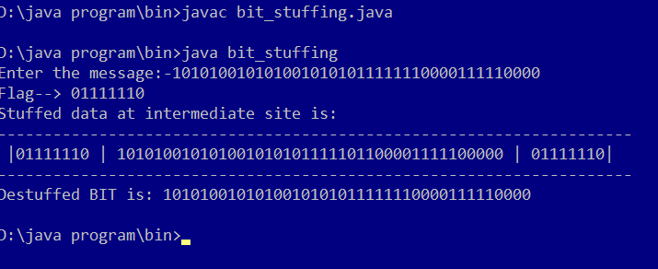

|  |  |
| --- | --- |
| **Ex No: 15** | **Communication Using PPP** |
| **Date:** |

# DESCRIPTION:

Point-to-Point Protocol is an industry-standard data-link layer protocol for wide area network (WAN) transmission that was developed in the early 1990s. Point-to-Point Protocol (PPP) allows Remote Access Service (RAS) products and devices from different vendors to interoperate for WAN communication.

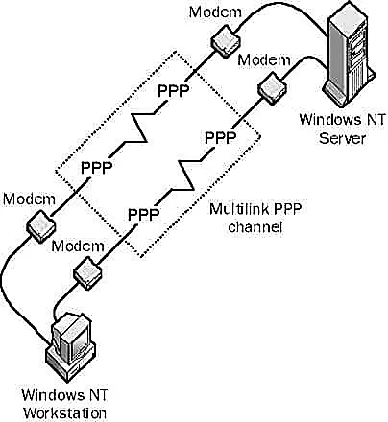

## Point to Point Protocol (PPP)

**How It Works?**

PPP supports the transmission of network packets over a serial point-to-point link by specifying framing mechanisms for encapsulating network protocols such as Internet Protocol (IP), Internetwork Packet Exchange (IPX), or NetBEUI into PPP frames.

PPP encapsulation is based on the High-level Data Link Control (HDLC) derived from the mainframe environment. These PPP frames can be transmitted over serial transmission lines such as Plain Old Telephone Service (POTS), Integrated Services Digital Network (ISDN), and packet-switched networks such as X.25.

PPP includes an extensible Link Control Protocol (LCP) for establishing, tearing down, and testing data-link WAN connections, as well as a number of Network Control Protocols (NCPs) for establishing and configuring network communication using each network protocol. PPP also supports a number of authentication schemes, such as Password Authentication Protocol (PAP) and Challenge Handshake Authentication Protocol (CHAP).

A typical dial-up session using PPP is completely automated and requires no real- time user input. It has four stages:

* Link establishment: PPP uses LCP to establish and maintain a PPP link over a serial transmission line. LCP frames are sent over the data link to test its integrity and establish the link.
* User authentication: PPP uses one of several authentication protocols, including PAP, CHAP, and Microsoft Challenge Handshake Authentication Protocol (MS- CHAP).
* Callback: PPP Callback Control (Microsoft’s implementation of PPP) uses Callback Control Protocol (CBCP) if it is configured.
* Configuration: NCPs are used to establish network connections, perform compression and encryption, lease IP addresses using Dynamic Host Configuration Protocol (DHCP), and so on. NCP frames are sent over the link to establish a network connection between the PPP server and the remote PPP client.